**To get Eclipse build path set up**

Right click on your project and choose Properties

Click on Java Build Path

Click on the Source tab

Remove whatever is already in the build path

Click Add folder

Choose the …/ltl/ltlgenerator/src folder

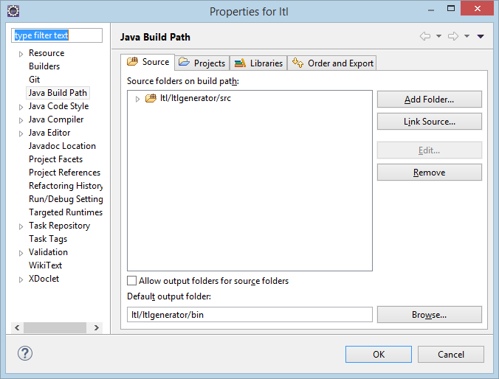

**To add the Junit libraries to your classpath**

Click Libraries

Click Add jars

Navigate to the lib folder and select the two far files

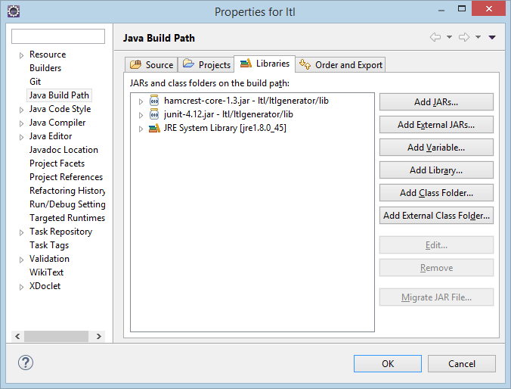

**To run the JUnit tests**

Open test.edu.tx.utep.ltlgenerator.CPGeneratorTest

Take a look at it. Pretty!

Right click on the CPGeneratorTest in the Project Explorer and choose Debug As -> Junit Test

(or alternatively Run As -> Junit test. I personally always debug everything. Never know when you need to set a break point)

A window will open and show you the results

Screen shots:

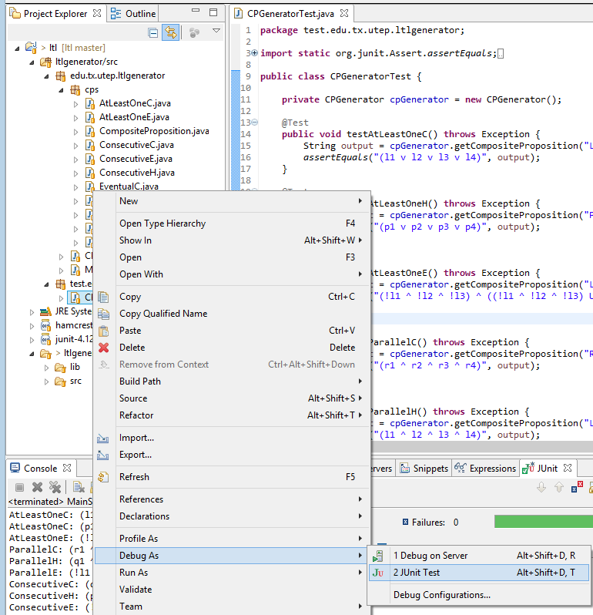

Output

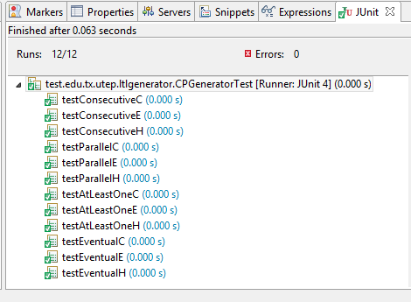

Output if something is wrong:

